

North South University

DEPARTMENT OF ELECTRICAL AND COMPUTER ENGINEERING

PROJECT REPORT

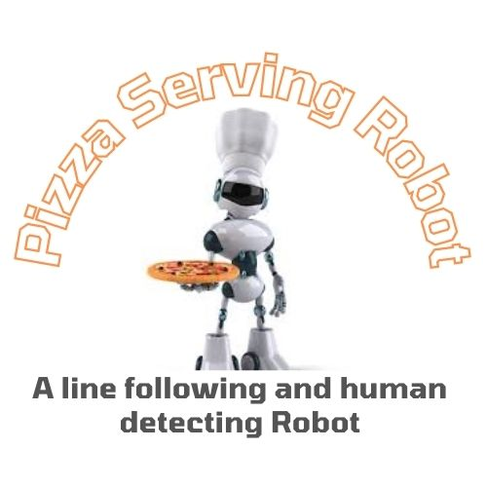

JUNIOR DESIGN

CSE299

SECTION: 10

SPRING 2023

Team Members

Barsha Talukdar 2013929642

Shah Nadim Kamran Rian 2012780042

Tanvir Rahman Navin 2012440642

Shadman Sakib Ayan 2014172642

Guided By: Nova Ahmed(NVA)

Submission date : 29 May, 2023

Declaration

We, the undersigned, hereby declare that this project report titled "Pizza-Serving Robot" represents our own work and that it has not been submitted elsewhere for academic credit. We acknowledge that any external sources used have been properly cited.

**Students’ names & Signatures**



__________________________

Barsha Talukdar

ID: 2013929642

Department of Electrical and Computer Engineering

North South University

Dhaka, Bangladesh



__________________________

Shah Nadim Kamran Rian

ID: 2012780042

Department of Electrical and Computer Engineering

North South University

Dhaka, Bangladesh



________________________

Tanvir Rahman Navin

ID: 2012440642

Department of Electrical and Computer Engineering

North South University

Dhaka, Bangladesh



__________________________

Shadman Sakib Ayan

ID: 2014172642

Department of Electrical and Computer Engineering

North South University

Dhaka, Bangladesh

Approval

The junior project report on ’Pizza Serving Robot’ has been submitted by Barsha Talukdar (ID: 2013929642), Shah Nadim Kamran Rian (ID: 2012780042) Tanvir Rahman Navin (ID: 2012440642) and Shadman Sakib Ayan (ID: 2014172642) students of the Department of Electrical and Computer Engineering, North South University, Dhaka, Bangladesh. This report partially fulfills the requirement for the degree of Bachelor of Science in Computer Science and Engineering in Spring 2023 and has been accepted as satisfactory.

**Supervisor’s Signature:**

__________________________

Dr. Nova Ahmed

Professor

Department of Electrical and Computer Engineering

North South University

Dhaka, Bangladesh

**Department Chair’s Signature:**

__________________________

Dr. Rajesh Palit

Professor and Chair (Acting)

Department of Electrical and Computer Engineering

North South University

Dhaka, Bangladesh

Acknowledgement

All praises are due to Almighty Allah, Most Gracious, Most Merciful who blessed us to be here at North South University for pursuing the bachelors degree.

We are grateful and wish our profound indebtedness to Dr. Nova Ahmed, Professor, Department of Electrical and Computer Engineering (ECE), North South University, Dhaka. We are blessed with the deep knowledge and keen interest of our supervisor in the field of design to carry our this project. Her guidance, constant supervision, enthusiastic encouragement, sagacious advice and an effective surveillance throughout the entire period of the project have made it possible to complete this project.

We would like to express deepest appreciation towards Dr. Rajesh Palit, Professor and Chair (Acting) of Electrical and Computer Engineering Department, North South University, Dhaka, Bangladesh.

We would also like to thank each and everyone who were involved in the project from our friends, faculty members, fellow classmates, juniors and seniors who took the time to help and guide us during the span of the project.

We would also like to thank our family members, our parents, brothers and sisters who are the very reason of our existence. Without their unconditional love and support, this project could not be completed.

Barsha Talukdar

Tanvir Rahman Navin

Shah Nadim Kamran Rian

Shadman Sakib Ayan

Abstract

The pizza-serving robot is an autonomous system designed to serve pizza slices to customers in a controlled environment. This project report provides a detailed account of the design, development, and implementation of the pizza-serving robot. It outlines the project's objectives, methodology, key features, challenges faced, lessons learned, and potential future improvements. The robot utilizes various sensors, including an IR sensor for line following and an ultrasonic sensor for detecting humans, along with an Arduino Uno as the main controller and an L298 motor driver for motor control.

Table of Contents Page

1. Introduction 07
2. Why We Need This Project 07
3. Project Definition 08
4. Purpose of Our Project/Motivation 08
5. Objective 08
6. Methodology 09
7. Procedure 10
8. Circuit Diagram 11
9. The Resources 11
10. A. Code 12

B. Result & analysis 14

1. Features 14
2. Project Goal 15
3. Project Schedule 16
4. Challenges Faced 16
5. Lessons Learned 17
6. Future Improvements 17
7. Maintenance Plan 18
8. Contribution 20
9. Conclusion 20
10. Introduction:

Automation has become increasingly prevalent in various industries, revolutionizing processes and enhancing efficiency. The food service sector is no exception, as businesses seek innovative solutions to streamline operations and provide enhanced customer experiences. The pizza-serving robot project addresses this need by developing an autonomous system capable of serving pizza slices to customers in a controlled environment.

This report presents a comprehensive overview of the pizza-serving robot project, detailing its objectives, methodology, key features, challenges encountered, lessons learned, and potential future improvements.

The pizza-serving robot project represents an innovative solution for automating the pizza serving process. By combining robotics, sensors, and intelligent control systems, the project contributes to the advancement of automation technologies in the food service industry.

1. Why We Need This Project:

The primary objective of this project is to automate the pizza serving process in order to enhance efficiency, reduce human error, and provide a unique dining experience for customers. By employing robotics and sensor technology, the pizza serving robot eliminates the need for human intervention during the delivery process, allowing restaurant staff to focus on other important tasks. This project also aims to showcase the potential applications of robotics in the food service industry.

1. Project Definition

The pizza-serving robot is designed to operate in a predefined area where it can follow a designated line using an IR sensor and detect humans using an ultrasonic sensor. The robot's primary components include an Arduino Uno microcontroller for controlling the robot's movements and a L298 motor driver for driving the robot's motors. The IR sensor allows the robot to follow a black line on a white background, while the ultrasonic sensor detects the presence of humans in its vicinity.

1. Purpose of Our Project/Motivation

The main purpose of the pizza-serving robot project is to demonstrate the potential of autonomous systems in the food service industry. By automating the process of serving pizza slices, the project aims to enhance efficiency, reduce human error, and improve customer experience. The motivation behind this project stems from the increasing demand for automation and robotics in various sectors, including food service, where repetitive tasks can be efficiently handled by machines.

1. Objective

The objective of the pizza-serving robot project is to develop an autonomous system capable of efficiently serving pizza slices to customers in a controlled environment. The specific objectives include:

* Designing a robot that can follow a designated line using an infrared (IR) sensor for precise navigation.
* Implementing an ultrasonic sensor to detect the presence of humans and enable the robot to stop for customer convenience.
* Incorporating mechanisms for autonomous pizza slice retrieval from a designated location, such as a car or specific area.
* Ensuring smooth and reliable operation through the integration of error handling mechanisms to handle unexpected situations or errors.
* Creating a user-friendly interface for customer interaction, providing visual and/or audio cues to indicate the robot's status and engage with customers.

1. Methodology

The pizza-serving robot project follows a systematic methodology to achieve its objectives. The methodology includes the following steps:

* Research and Analysis: Conduct a thorough review of existing pizza-serving robot systems, automation technologies, and relevant sensor technologies. Analyze their strengths, limitations, and potential applications in the context of the project.
* System Design: Based on the research and analysis, design the overall system architecture and select appropriate components such as microcontrollers, motor drivers, and sensors. Consider factors such as size, power requirements, and compatibility.
* Sensor Integration: Integrate the infrared (IR) sensor and ultrasonic sensor into the robot's design. Calibrate the sensors to ensure accurate readings and reliable performance.
* Motor Control: Implement the L298 motor driver to control the robot's movement. Develop algorithms for precise motor control, allowing the robot to follow the designated line smoothly and make necessary adjustments for accurate navigation.
* Error Handling: Integrate error handling mechanisms to detect and recover from sensor failures, motor malfunctions, or unexpected events during operation. Implement appropriate algorithms to handle errors and ensure the robot's reliable performance.
* User Interface: Develop a user-friendly interface to facilitate customer interaction. Incorporate visual indicators or audio cues to communicate the robot's status and engage with customers effectively.
* Testing and Iteration: Conduct thorough testing of the pizza-serving robot system to evaluate its performance, reliability, and accuracy. Iterate and make necessary adjustments based on testing results to enhance the system's functionality and address any identified issues.
* Documentation: Document the design, implementation, and testing process in a project report, including the challenges faced, lessons learned, and potential areas for future improvement.

By following this methodology, the pizza-serving robot project aims to develop a functional and efficient autonomous system capable of serving pizza slices to customers in a controlled environment.

1. Procedure

* **Hardware Setup:** The pizza serving robot is built using an Arduino Uno microcontroller board, an L298 motor driver, ultrasonic sensors, and IR sensors. The components are connected according to the circuit diagram, ensuring proper wiring and connections.
* **Programming:** The Arduino Uno is programmed to control the motors, process data from the sensors, and make decisions based on the inputs received. The program includes algorithms for obstacle detection using ultrasonic sensors and line following using IR sensors. It also incorporates logic for path planning and delivering pizzas to designated tables.
* **Motor Control:** The L298 motor driver is used to control the motors responsible for the robot's movement. By sending appropriate signals to the motor driver from the Arduino Uno, the robot can move forward, backward, turn left, and turn right as required.
* **Obstacle Detection**: Ultrasonic sensors are utilized to detect obstacles, particularly humans, in the robot's path. The sensors emit ultrasonic waves and measure the time it takes for the waves to bounce back. By analyzing the reflected waves, the robot can determine the distance to an obstacle and take appropriate actions to avoid collisions.
* **Line Following:** IR sensors are employed to enable the robot to follow a designated path. The sensors detect the contrast between the line and its surroundings, allowing the robot to stay on track. The program instructs the robot to make necessary adjustments to maintain the desired trajectory.
* **Pizza Delivery:** The robot is designed to carry a tray capable of holding pizza slices. Once the robot reaches the designated table, it stops and waits for the customer to take the pizza. The tray can be easily removed, allowing the customer to access the pizza boxes.

1. Circuit Diagram

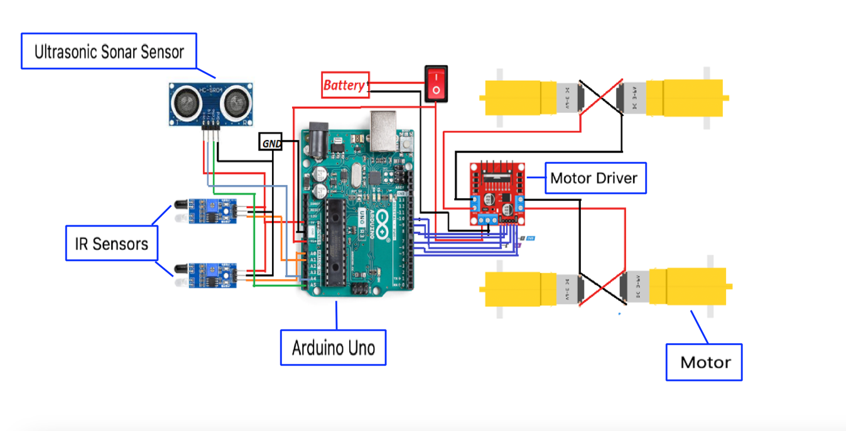

Figure 1: circuit diagram

1. The resources

Hardware:

Arduino Uno R3 Motor wheel(4 Nos)

L293D motor driver shield IR sensor(2 Nos)

Lippo Battery(9v) PVC Board

Screw-20taka Switch- 10 taka

wires- 100 Breadboard- 150 taka

Software: Arduino IDE 2.0.3



A| Code

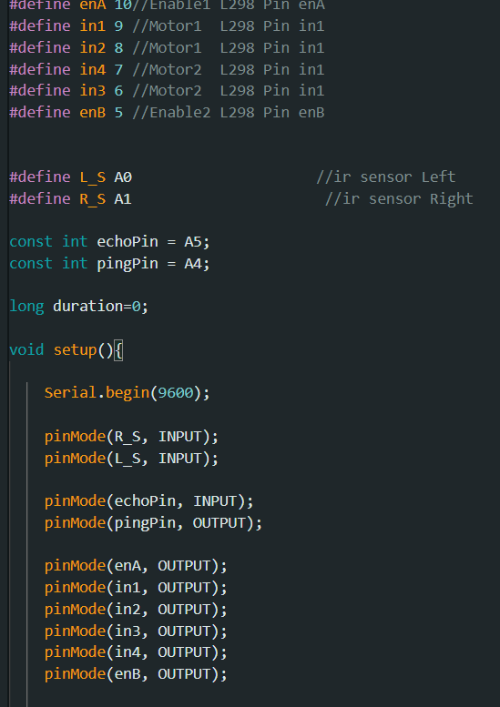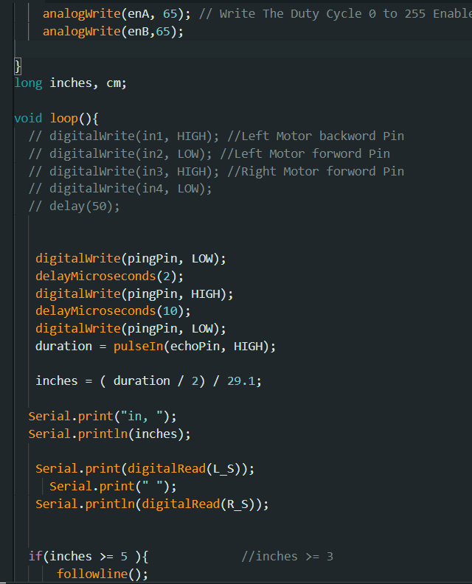

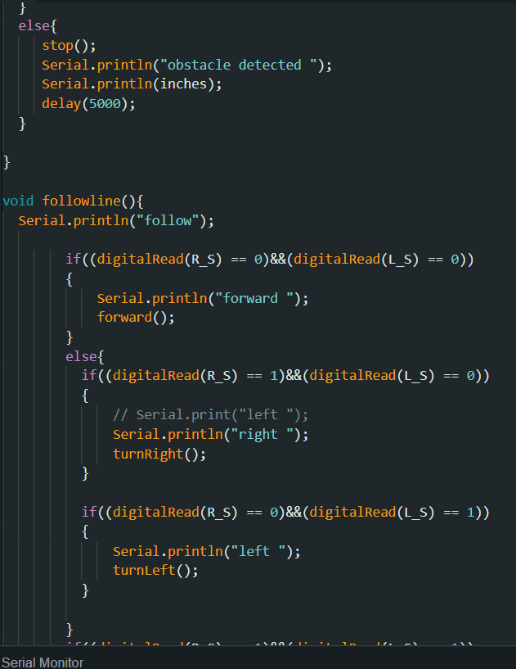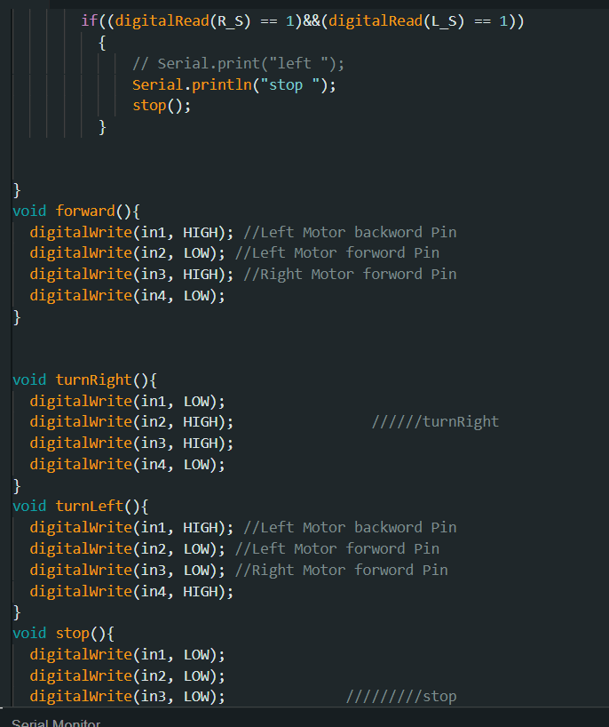

B| Result & analysis:

Present Condition of our robot:

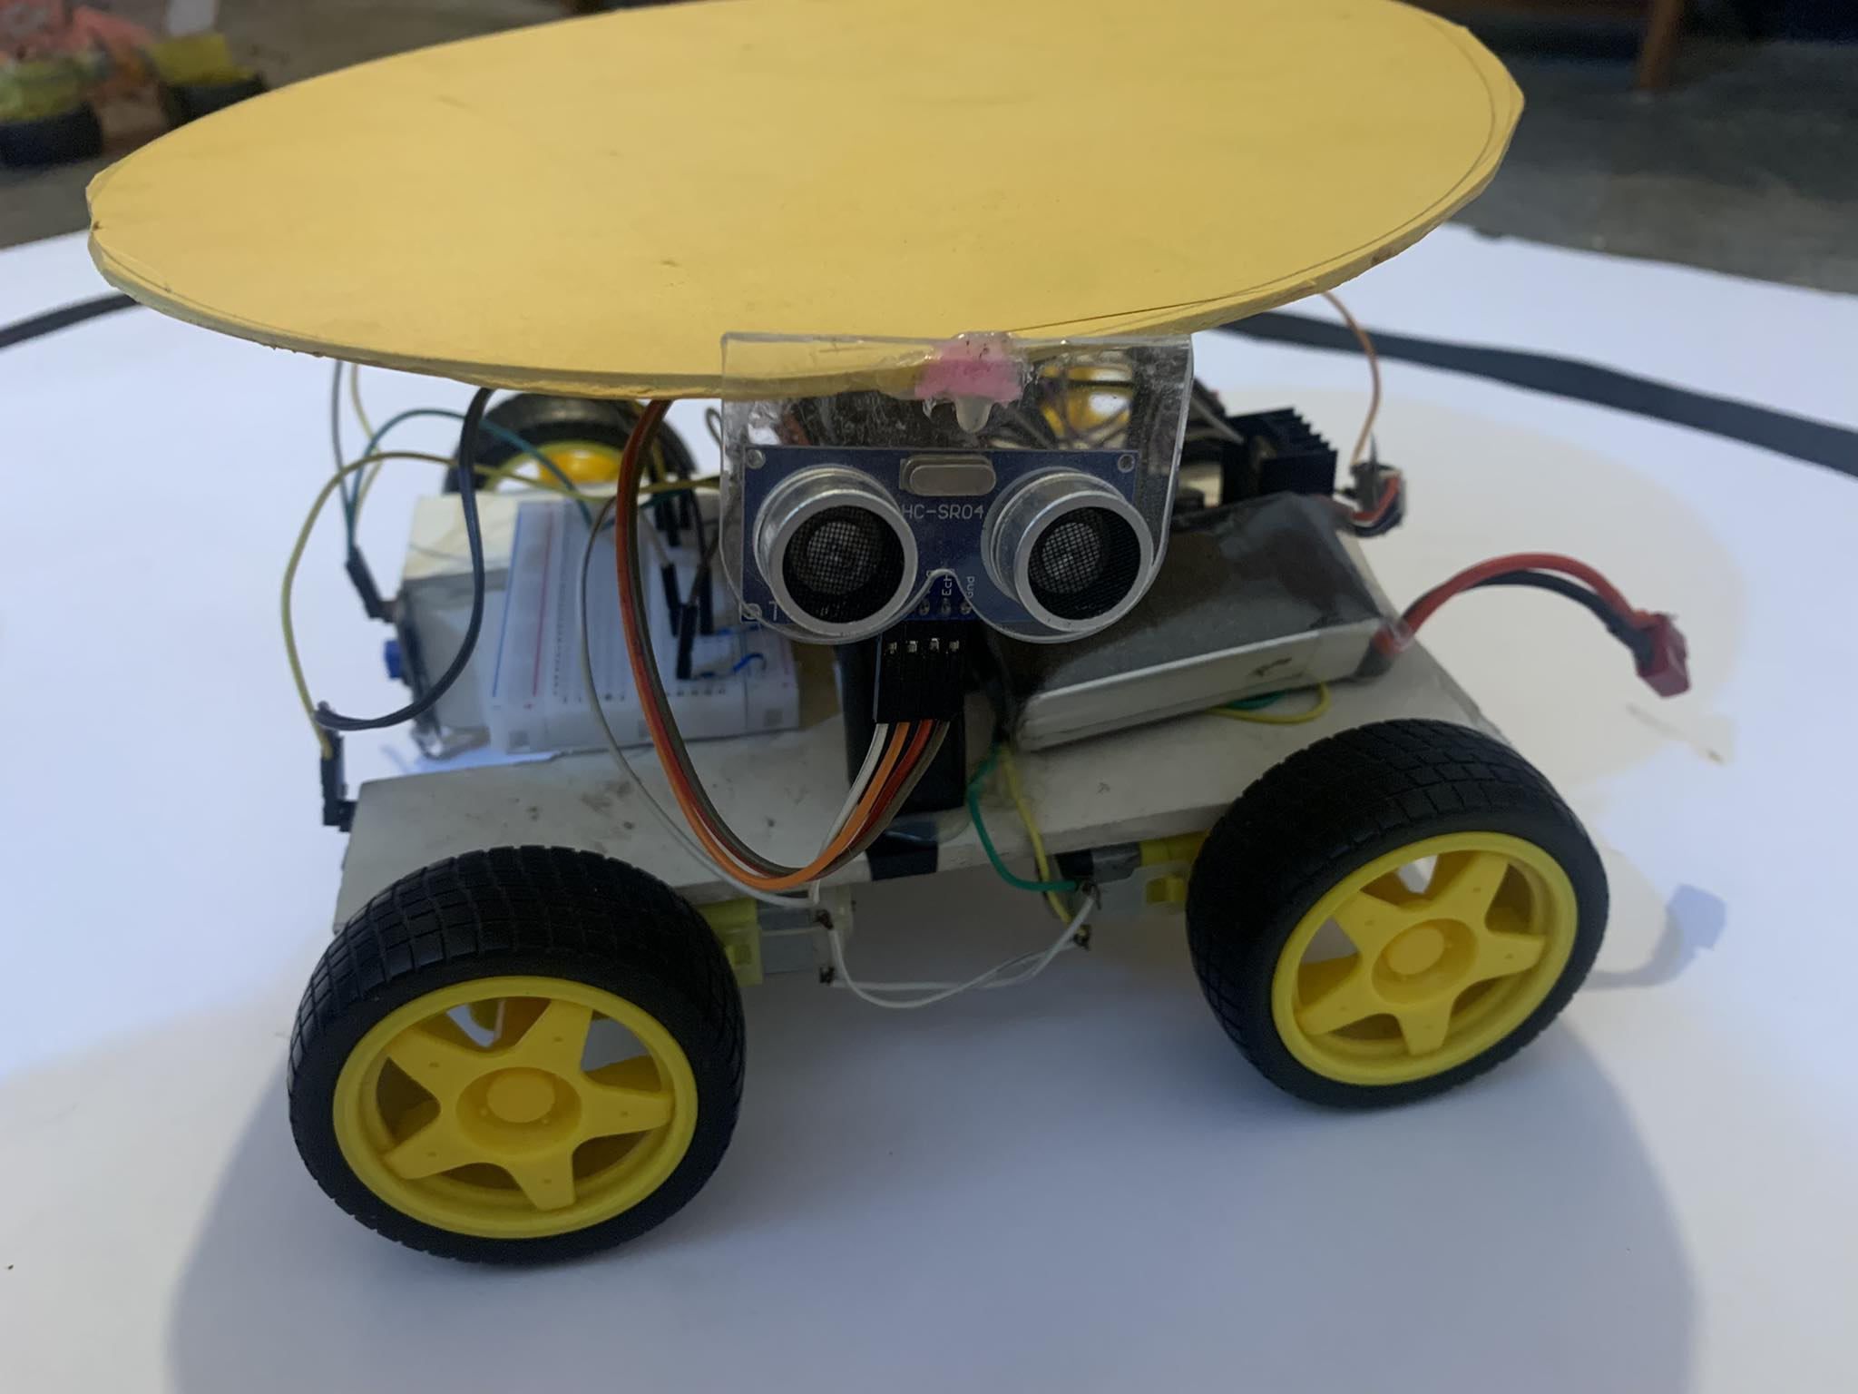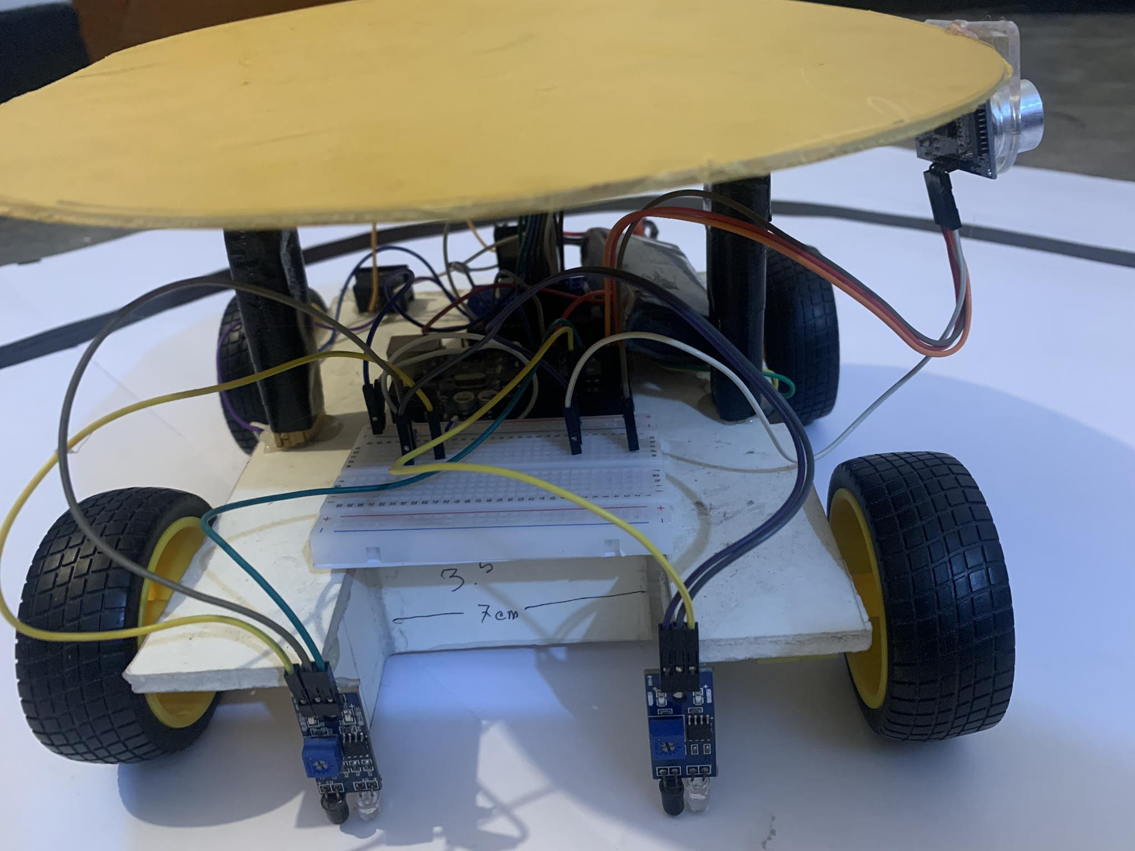

Figure 2: Picture of the Robot

This robot follows a line and if anything comes in 5cm range of its ultrasonic sensor the car will stop for 5 second. After 5 second it will start again. When both sensor detects non-black surface the car will stop.

We have tested this robot several times and it worked perfectly so far.

1. Features

The pizza-serving robot incorporates several features to ensure efficient and reliable pizza slice delivery. These features include:

* **Line Following:** The robot utilizes an IR sensor to accurately follow a designated black line on a white background, ensuring precise navigation to the desired location.
* **Human Detection:** An ultrasonic sensor is employed to detect the presence of humans in the robot's path. Upon detection, the robot stops to ensure the safety and convenience of customers.
* **Autonomous Operation:** The robot operates autonomously, executing predefined tasks without the need for continuous human intervention.
* **Error Handling:** The robot incorporates error handling mechanisms to handle unexpected situations or errors during operation. It can detect and recover from sensor failures, motor malfunctions, or other unforeseen circumstances.
* **Customer Interaction:** The robot is designed to provide a seamless customer experience. It can display visual indicators or provide audio cues to indicate its status and engage with customers, creating an interactive and user-friendly environment.

1. Project Goal

The primary goal of the pizza-serving robot project is to develop a fully autonomous system capable of efficiently serving pizza slices to customers. The specific objectives include:

* Designing a robot capable of following a designated line using an IR sensor.
* Implementing an ultrasonic sensor to detect the presence of humans and enable the robot to stop for them.
* Incorporating mechanisms for autonomous pizza slice retrieval.
* Ensuring smooth and reliable operation through the integration of error handling mechanisms.
* Creating a user-friendly interface for customer interaction.

1. Project Schedule

|  |  |  |  |  |  |  |  |
| --- | --- | --- | --- | --- | --- | --- | --- |
| **Task** | **Weeks** | | | | | | |
| **1-2** | **3-4** | **5-6** | **7-8** | **9-10** | **11-12** | **13-14** |
| **Collection of equipment** |  |  |  |  |  |  |  |
| **Set up the car with all necessary parts** |  |  |  |  |  |  |  |
| **Connection of all sensor and motor with Arduino uno, Calibrate the sensor** |  |  |  |  |  |  |  |
| **Testing and Bug Fixing** |  |  |  |  |  |  |  |

Figure 3: Schedule

1. Challenges faced

Throughout the development of the pizza-serving robot, several challenges were encountered. These challenges included:

**Sensor Calibration:** Calibrating the IR sensor and ultrasonic sensor to provide accurate and reliable readings required thorough testing and adjustment.

**Motor Control:** Achieving precise motor control for accurate movement and positioning of the robot posed challenges in terms of synchronization and speed control.

**Object Detection and Localization:** Ensuring efficient and accurate human detection and localization using the ultrasonic sensor presented challenges due to varying environmental conditions and sensor limitations.

**Battery issue:** Managing the power supply and addressing battery limitations emerged as a significant challenge. The robot required a sufficient and reliable power source to ensure continuous operation. Strategies such as optimizing power consumption and exploring alternative power solutions were implemented to mitigate the battery issue.

1. Lesson Learned

The pizza-serving robot project provided valuable lessons and insights that can guide future endeavors. Key lessons learned from the project include:

* **Importance of Testing and Calibration:** Thorough testing and calibration of sensors and motors are crucial for accurate and reliable robot operation. Regular testing and fine-tuning helped identify and address issues promptly, ensuring optimal performance.
* **Iterative Development Process:** Adopting an iterative development process, involving incremental improvements and continuous testing, proved to be an effective approach for troubleshooting and enhancing the robot's performance. This iterative approach allowed for iterative refinements and adjustments, leading to an improved final system.
* **Collaboration and Communication:** Effective collaboration and communication among team members were essential for problem-solving and project progress. Regular team meetings, sharing of insights and challenges, and clear communication channels contributed to the project's success.

1. Future Improvements

While the pizza-serving robot successfully accomplished its primary objectives, there are opportunities for future improvements. These include:

* **Enhanced Object Detection:** Improving the accuracy and reliability of human detection by implementing advanced sensor fusion techniques or integrating additional sensors, such as cameras to enhance object detection capabilities. This would enable the robot to accurately identify and respond to customers in various scenarios, ensuring a seamless and efficient serving experience.
* **Automatic Pizza Delivery System:** Introducing an automatic pizza delivery system by incorporating a servo motor mechanism. This enhancement would allow the robot to autonomously retrieve pizza slices from the designated location, ensuring smooth and reliable delivery to customers without requiring human intervention.
* **Power Management:** Addressing the battery issue by implementing more efficient power management strategies or exploring alternative power solutions, such as rechargeable or swappable battery systems. Optimizing power consumption and integrating energy-saving features would extend the robot's operating time and minimize downtime for battery replacement or recharging.
* **User Interaction and Feedback:** Enhancing the user interface to provide more interactive and engaging customer experiences. This could involve integrating a touch screen or voice recognition system, allowing customers to interact with the robot more naturally. Additionally, incorporating a feedback mechanism, such as a display or audible cues, would enable the robot to communicate its status and progress to customers effectively.

By focusing on these future improvements, the pizza-serving robot can continue to evolve and meet the changing demands of the food service industry. These enhancements would enhance its functionality, efficiency, and overall customer satisfaction, further cementing its role as an innovative solution in the automation of pizza serving.

1. Maintenance Plan

To ensure the continued optimal performance and longevity of the pizza-serving robot, a comprehensive maintenance plan should be implemented. This plan includes regular inspections, cleaning, and preventive maintenance procedures. By adhering to a well-defined maintenance schedule, potential issues can be identified and addressed promptly, minimizing downtime and maximizing the robot's operational efficiency.

1. **Regular Inspections:**

* Conduct routine visual inspections of the robot's components, including sensors, motors, cables, and connectors, to check for any signs of damage or wear.
* Inspect the robot's wheels and ensure they are clean and free from debris that may affect the robot's navigation.
* Verify the condition of the power supply and check for any loose connections or frayed cables.

1. **Cleaning:**

* Clean the robot's exterior surfaces using a soft cloth and mild cleaning agents to remove dust, dirt, and any food residues that may have accumulated during operation.
* Pay special attention to the sensors and ensure they are free from any obstructions or contaminants that could impact their performance.

1. **Sensor Calibration:**

* Regularly calibrate the infrared (IR) sensor and ultrasonic sensor to maintain accurate readings and reliable performance.
* Follow the manufacturer's guidelines for calibration procedures or consult technical documentation for proper calibration instructions.

1. **Motor Maintenance:**

* Monitor the motor performance and listen for any unusual sounds or vibrations during operation. If abnormalities are detected, inspect the motor and its connections for any issues.
* Lubricate the robot's motors as per the manufacturer's recommendations to ensure smooth and efficient movement.

1. **Battery Maintenance:**

* Check the battery's condition and ensure it is charging properly. Inspect the battery contacts and terminals for any corrosion or damage.
* Follow proper charging and discharging procedures to prolong the battery's lifespan.
* If battery degradation is observed, consider replacing the battery with a new one to maintain optimal power supply.

By implementing a well-structured maintenance plan and adhering to it consistently, the pizza-serving robot can operate at its full potential, minimize downtime, and deliver efficient and reliable pizza-serving services to customers.

1. Contribution

* Barsha Talukdar- Mainly coding part and testing issue was handled.
* Shah Nadim Kamran Rian- motor driver connections, arduino connections, testing.
* Shadman Sakib Ayan- Sensor calibration, testing.
* Tanvir Rahman Navin- Testing of both sensor, testing.

1. Conclusion

The pizza-serving robot project successfully developed an autonomous system capable of serving pizza slices to customers in a controlled environment. The integration of IR and ultrasonic sensors, along with the Arduino Uno microcontroller and L298 motor driver, facilitated precise line following, human detection, and autonomous slice retrieval. The project encountered challenges that were effectively addressed, and valuable lessons were learned throughout the development process. With future improvements and enhancements, the pizza-serving robot has the potential to revolutionize the food service industry by automating repetitive tasks, improving efficiency, and enhancing customer experience.

THANK YOU